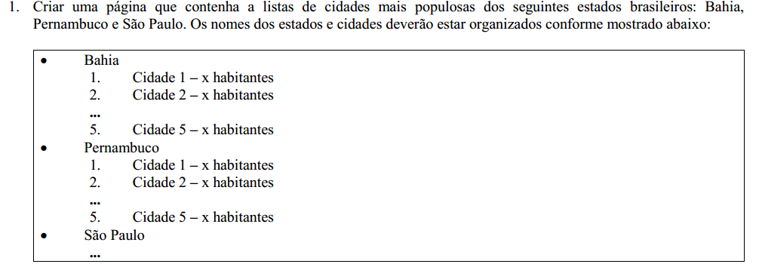

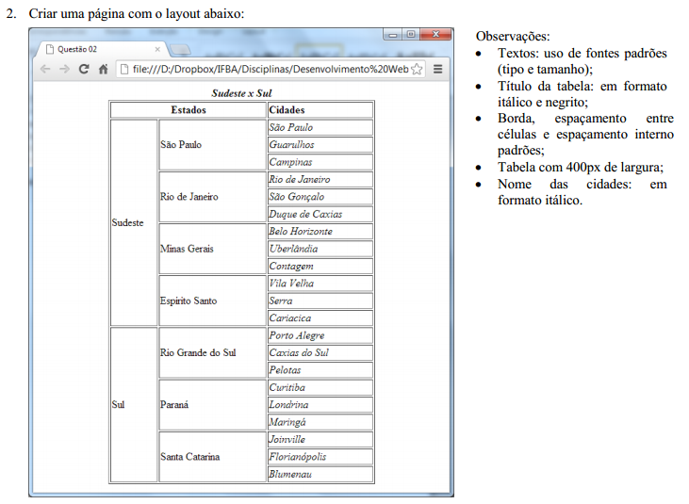

Link ajuda: <https://www.w3schools.com/html/html_tables.asp>